**Embargoed until September 28, 2014, 08:00 CEST**

**Gap between reported and actual fuel economy higher than ever before**

*The gap between official and real world fuel-economy figures has reached more than 30 per cent, causing motorists to spend an average of €450 per year more on fuel than if that non-performance gap were closed, new research shows. Ten years ago the discrepancy between these real-world and sales-brochure values was at 10 per cent.*

*These are two key findings from a new report based on data from more than half a million private and company vehicles across Europe, which was published today in Berlin by the International Council on Clean Transportation (ICCT), an independent research organisation. The findings come as the European Commission is preparing to adopt an improved test procedure that would produce more realistic vehicle test results.*

The new report, jointly prepared by the ICCT, the Netherlands’ Organisation for Applied Scientific Research (TNO), and Germany’s Institut für Energie- und Umweltforschung Heidelberg (IFEU), unveils the increasing real-world efficiency gap using systematic statistical analysis.

“All data sources confirm that the gap between sales-brochure figures and the real world continues to grow,” says Dr. Peter Mock, Managing Director of ICCT Europe. “Two years ago the gap was still around 25 per cent. Now it has increased to 31 per cent for private cars, and even higher for company cars.”

The analysis draws on data from a number of different sources: the user websites spritmonitor.de (Germany) and honestjohn.co.uk (United Kingdom), the leasing companies Travelcard (Netherlands) and LeasePlan (Germany), the car and consumer magazines AUTO BILD (Germany), auto motor sport (Germany), WhatCar? (United Kingdom) and the car club TCS (Switzerland). “Our analysis comprises on-road driving data from all across Europe, both private and company cars, all told nearly half a million vehicles”, summarizes Dr. Mock.

For the average vehicle owner, the discrepancy translates into about 450 euros additional spending for fuel per year, compared to a situation in which official and real world fuel consumption values were in line. Furthermore, the increasing gap more than halves the official CO2 reductions achieved during the last ten years, making it more challenging to meet the EU’s climate change mitigation objectives. For governments, the growing gap causes significant losses of tax revenues. This is because vehicle taxes are based on laboratory test results instead of real-world data. For the Netherlands alone, the loss in tax revenues could exceed €3.4 billion per year, according to the ICCT estimate.

One new feature in the 2014 report is an examination of vehicle models. When looking at individual vehicle models, the ICCT researchers reveal a common pattern: “When a new vehicle model generation is introduced, the gap suddenly increases from one year to another”, says Dr. Mock. “For cars that were introduced after 2009, the gap, on average, increases by 60 per cent with every model change or major facelift”. The researchers see in this a strong indication that changes in consumer behavior cannot explain the growing gap. Instead, it is likely that manufacturers are optimizing their vehicles more and more for the official test cycle instead of the real driving needs of the customers.

Manufacturers measure vehicle fuel consumption in a controlled laboratory environment, using a test procedure called the New European Driving Cycle (NEDC). This procedure was developed in the 1980s and was not originally intended to be used for fuel consumption testing but air pollutants. A new and more appropriate test procedure, the Worldwide Harmonized Light Vehicles Test Procedure (WLTP), has been developed through the United Nations and is ready for implementation in the EU as early as 2017. In the new test procedure, for example, the weight of the vehicles will be reflected more realistically – one of the aspects that will help to reduce the current fuel-economy gap.

“The new test procedure will fix a number of flaws in the current procedure, and it should be introduced in the European Union as quickly as possible,” concludes Dr. Mock, “It will not resolve all the open issues, but it will be a huge step toward correcting this discrepancy, which poses an increasing risk to efforts to make the European car fleet more energy efficient and less polluting.”

**From laboratory to road – A comparison of official and ‘real-world’ fuel consumption**

**and CO2 values for cars in Europe and the United States**

PDF download here (from September XXX on):

<http://www.theicct.org/laboratory-road-2014-update>

*The International Council on Clean Transportation (ICCT) is an independent nonprofit organisation founded to provide first-rate, unbiased research and technical and scientific analysis to environmental regulators. The ICCT participants’ council comprises high-level civil servants, academic researchers, and independent transportation and environmental policy experts, who come together at regular intervals to collaborate as individuals on setting a global agenda for clean transportation. ICCT was founded in 2005, and has offices in Berlin and Brussels, as well as in the US and China. It is funded principally by private foundations, such as the ClimateWorks Foundation in the US and Stiftung Mercator in Europe.*

**Contact:**

*Dr. Peter Mock*

*Managing Director ICCT Europe*

*Neue Promenade 6, 10178 Berlin, Germany*

*Phone: +49 (30) 847129-102*

*Email: peter@theicct.org*

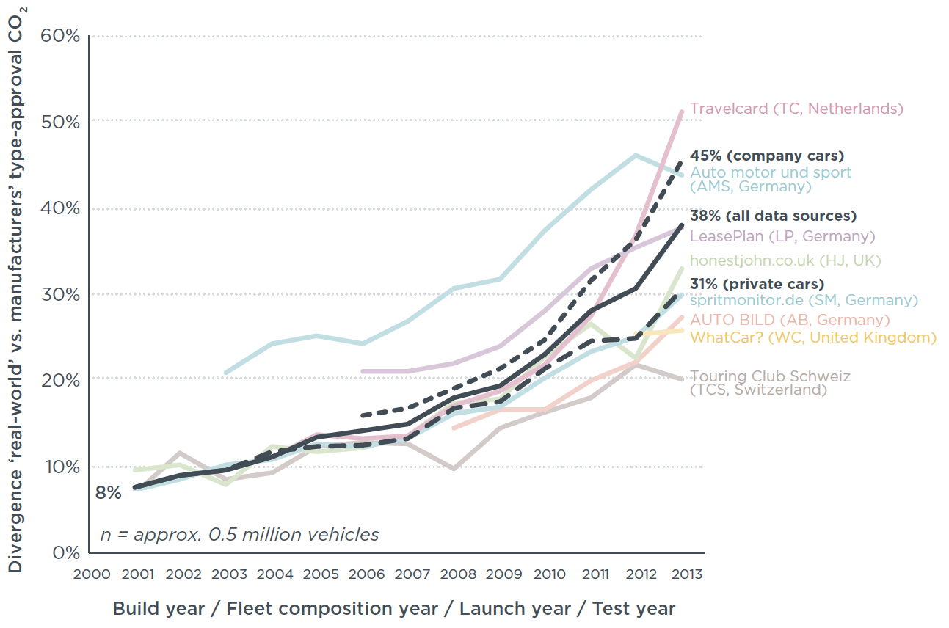

**

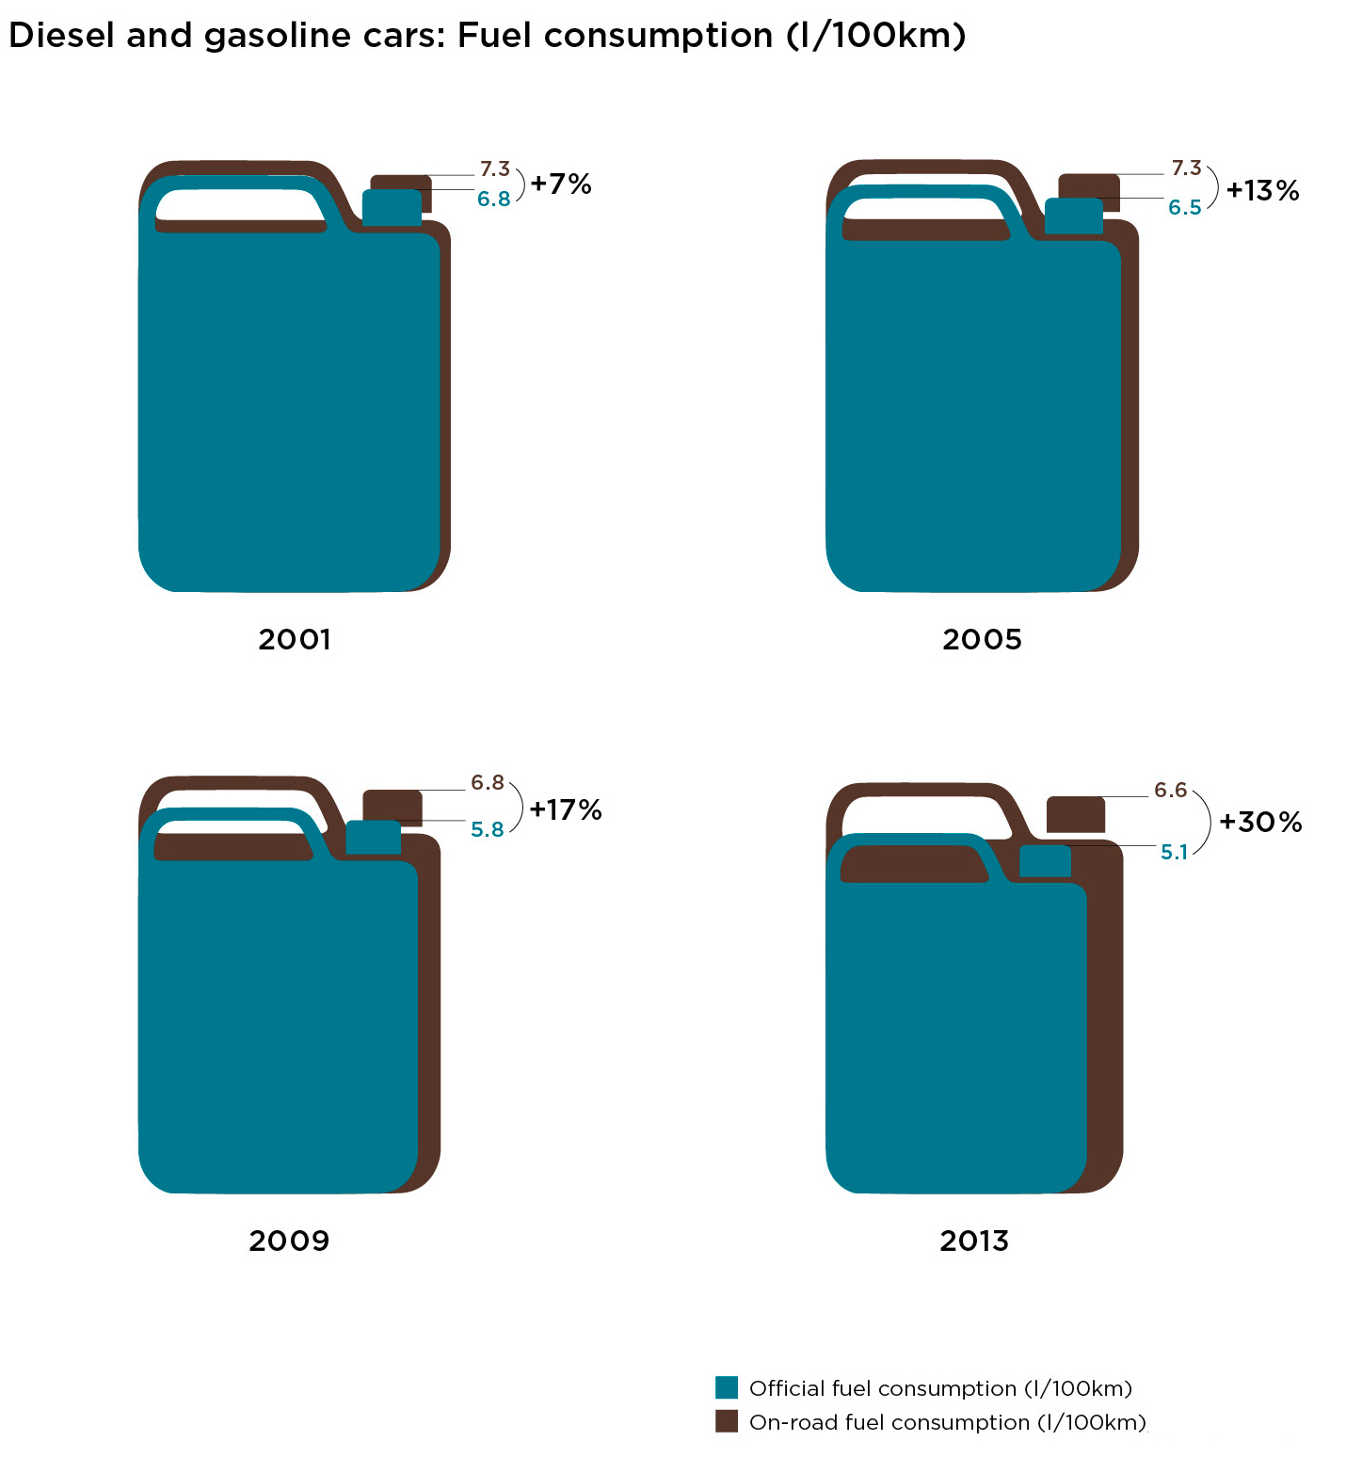

**Other contacts on the subject**

*Institut für Energie- und Umweltforschung Heidelberg (IFEU)*

*Mr. Udo Lambrecht*

*+49 (6221) 4767 35*

*udo.lambrecht@ifeu.de*

*Netherlands’ Organisation for Applied Scientific Research (TNO)*

*Dr. Norbert Ligterink*

*+31 (0) 888 668 058*

*norbert.ligterink@tno.nl*

*The European Consumer Organisation (BEUC)*

*Ms. Chris Carroll*

*+32 (0) 2 789 2754*

*Chris.Carroll@beuc.eu*

*Federation International de l’Automobile (FIA) (car clubs’ association)*

*Ms. Laurianne Krid*

*+32 (0) 2 282 0818*

*lkrid@fia.com*

*European Automobile Manufacturers Association (ACEA)*

*Mr. Petr Dolejsi*

*+32 2 738 7357*

*pd@acea.be*

*Transport Environment (T&E) (NGO umbrella organisation)*

*Mr. Greg Archer*

*+32 2 893 0849*

*greg.archer@transportenvironment.org*