Zero-emission commercial vehicle development: Webinar 5

Date: 2021.12.08
Staff contact: Shiyue Mao

Summary:
The 5th webinar, co-hosted by ICCT and CATARC, was held on December 8th, 2021 with the theme of local policies and actions to promote ZE-HDVs in subnational regions. Participants from EFC, VECC, EV100 and OEMs were invited to participate the Webinar and 6 speakers from CATARC-ADC, LA Mayor Office, Shenzhen Xieli Innovation Center (NEICV), SAIC Iveco Hongyan Co. Ltd, Xuzhou Construction Machinery Group and Netherlands Enterprise Agency (RVO) delivered presentations.

Key notes and takeaways:
- Lijie Jia, Directorial Engineer, CATARC-ADC
- Policy overview: It is aimed to substitute the subsidy mechanism with pilot projects and other promotion measures at national level; for local side, innovation on management is encouraged by local conditions.
- Market characteristics: ZE-HDVs have rebounded from a downward trend of sales, and products are growing mature and diverse in China. The cumulative sales from January to October of 2021 reached 126,600, with a year-on-year increase of 55.88%. It is expected that the annual sales will exceed 160,000.
- Market status: 1) urban logistics vehicle market is the main source of market growth, with a year-on-year increase of 133% from January to October of 2021, the market is dominated by economically advanced regions with a share of 84%; 2) the market of battery swapping HDVs is emerging with a cumulative sales of nearly 2,000 units from January to October of 2021, and the sales are mainly concentrated in areas with steeling industry and urgent needs on environmental improvement.
- Outlook for future development: electrification is a must-have due to carbon peaking and carbon neutrality target of China by 2030 and 2060, respectively. Local authorities shall draw comprehensive judgement based on economic, environmental, and political targets. ZE-HDVs are still at infant stage right now, but the market potential is huge and electrification transition of commercial vehicle is inevitable.
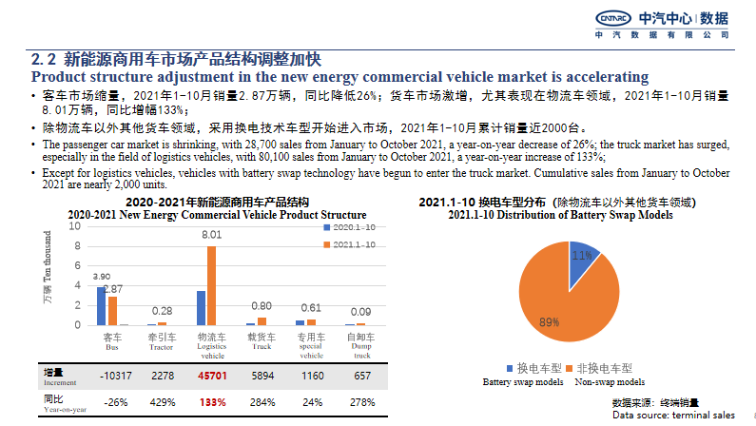

- Jessica Jinn Climate Consultant, LA Mayor Office
- California has set aggressive goals in transportation sector, which required that new cars and light duty trucks sold in California to achieve 100% zero emissions by 2035, and new medium and heavy-duty vehicles to achieve 100% zero emissions by 2045.
- There are two sets of guidance in California for promotion of ZE-HDVs’ deployment. The first mandate is Advanced Clean Trucks, or ACT, which focuses on promoting the large-scale transition of medium and heavy-duty vehicles (Class 2b-8) to zero emission. The other one is Advanced Clean Fleets, which is still being formulated, the goal of this policy is to transition fleets to zero emission.
- California's fiscal and tax incentives involve both direct purchase subsidies at the state level and indirect charging support at the city level. The state government has drafted a project for substituting hybrid and ZE-HDVs with vouchers (also known as HVIP), which has already funded purchase of over 7,500 zero emission and clean trucks. Los Angeles Department of Water and Power helps the fleets to realize electrification through commercial charging rebate.
- Los Angeles has set up ZE Delivery Zones and non-ZE vehicles parked in ZE Delivery Zones will be imposed fines. In addition, Port of Los Angeles has approved a clean truck fund rate, which charges cargo owners a fee for utilizing trucks that do not meet clean air standards.

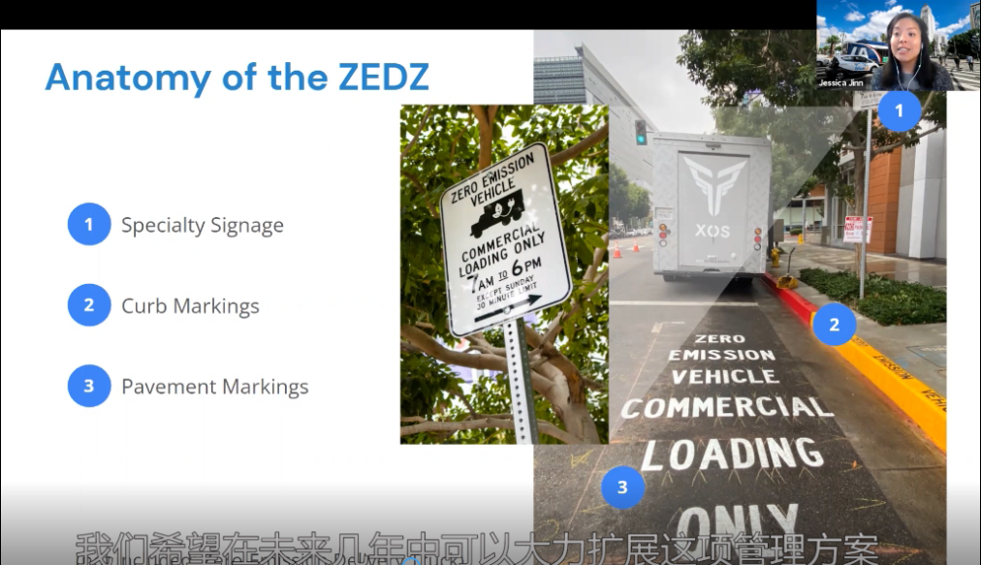

- Haiming Xie, Director, Shenzhen Xieli Innovation Center of Vehicles (NEICV)
- Market statistics: by 2020, the total number of motor vehicles in Shenzhen is about 3.59 million, and new energy vehicles are about 0.45 million, accounting for 12.6% of total motor vehicles. The field of public transportation (including buses, taxis, and car-hailing) has basically achieved full electrification. Zero emission light duty utility vehicles are also greatly adopted for use recently, including sanitation vehicles and dump trucks.
- Policy measures: there are three types of policy in Shenzhen for incentive purpose, i.e., long term targets, financial subsidy, and specialized policy. Since 2009, 6 targets were released, which set straightforward goals for NEVs promotion and charging infrastructure deployment by time and vehicle segment in Shenzhen; subsidy policies were also released, covering private-use purchase subsidy as well as commercial-use subsidies on bus, taxi and dump trucks; other specialized policies consist of several measures such as parking discounts, environmental subsidies for utility vehicle operation, and driving privilege for zero emission vehicles in "Green Logistics Zone".
- Next step: The proportion of NEVs shall reach 60% and the population of NEVs in Shenzhen shall exceed 1 million by 2025.
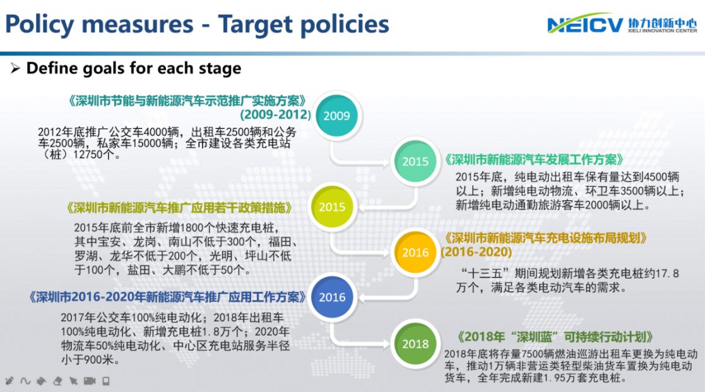

- Yun Qiao, NEV Director, SAIC Iveco Hongyan Co. Ltd
- Battery swapping applications: several application scenarios, such as coal freight, container, urban construction freight, and short distance freight, etc., are considered to be appropriate for battery swapping technology. In 2020, 20,000 tons of cargos have been delivered by autonomous battery swapping heavy-duty trucks in a pilot port, the total weight is established to 100,000 tons in 2021, with the fleet size growing to over 30 vehicles.
- Barriers for application of battery swapping technology: high purchase cost of vehicle, battery degradation and long charging time are the main obstacles of promoting electric heavy-duty trucks. Battery swapping trucks can take the advantage of lower purchase cost and shorter charging time by applying innovative business model and with battery swapped, compared to traditional electric heavy-duty vehicles.
- Market outlook: the share of battery swapping heavy-duty trucks in the electric heavy-duty truck fleet will increase to 70% by 2025 with a total population of ~90,000.
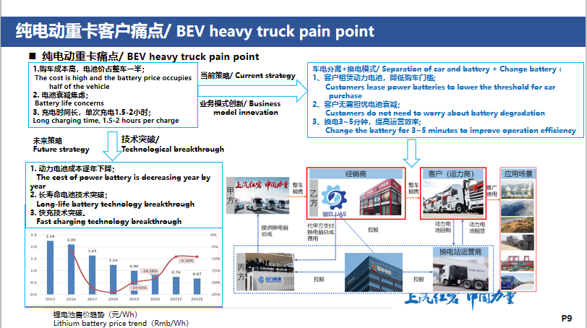

- Mingxing Zhuang, Director, Xuzhou Construction Machinery Group (XCMG)
- Operation of XCMG's battery swapping vehicles in Xuzhou city: Xuzhou No. 1 battery swapping station is the first pilot project for battery swapping construction freight trucks in Chinese cities. The whole battery swapping process takes only about 5 minutes by smart control. There are already 90 vehicles in operation to date, and more than 1,500 construction freight trucks in the urban area of Xuzhou will be replaced by electric trucks by 2025, according to the plan of Xuzhou local authority. The setup of Xuzhou No. 2 battery swapping station is about to be completed, which will further promote ZE-HDVs in Xuzhou.
- Application in other cities: with facilitation of Keyi battery swapping station, 30 XCMG battery swapping trucks have been operated in Suixian County, Henan Province in early 2021. Since then, XCMG has deployed more than 500 battery swapping vehicles in Handan County, Ganglu County, Xinjiang UAR and Henan Province.
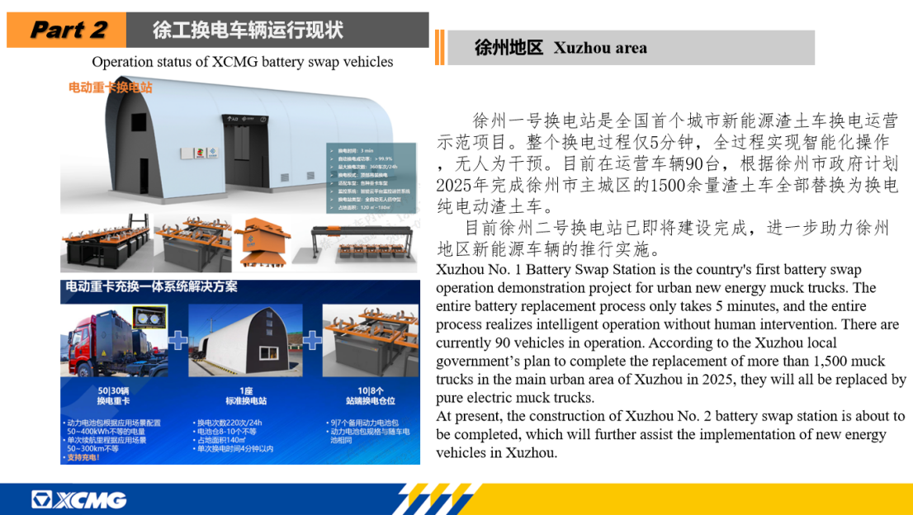

- Rosemarie Cramer, International Sustainable Logistic Consultant, Netherlands Enterprise Agency (RVO)
- Re-set of carbon reduction target: the Netherlands initially issued its target at the national level in 2019 to achieve 49% carbon emission reduction by 2030. After release of "Fit for 55" by EU, the emission reduction target was adjusted to 55%.
- The Netherland aims to cut down carbon emissions from transportation sector with zero emission zones (ZEZ). The ultimate goal is to establish zero emission zones in 30-40 cities by 2025. Currently, zero emission requirements are imposed in some specific application fields, such as fire trucks, waste recycling vehicles and logistics vehicles in cities.
- The driving restriction of ZEZs will not only increase the sales of new electric vehicles, but also stimulate the zero-emission transition of fleets.
- Challenges: 1) difficulty to identify whether foreign vehicles are zero-emission or not due to lack of information; 2) infrastructure needs; 3) application scenarios of ZE-HDV still need to be explored further.
